**3 Game**

1. **Game Ular**

Index.html

<!DOCTYPE html>

<html lang="id">

<head>

<meta charset="UTF-8" />

<meta name="viewport" content="width=device-width, initial-scale=1" />

<title>Game Ular</title>

<link rel="stylesheet" href="style.css" />

</head>

<body>

<h1>Game Ular</h1>

<div class="game-area">

<canvas id="gameCanvas" width="400" height="400"></canvas>

</div>

<p>Score: <span id="score">0</span></p>

<button id="restartBtn">Mulai Ulang</button>

<script src="script.js"></script>

</body>

</html>

CSS

body {

font-family: Arial, sans-serif;

background-color: #222;

color: #eee;

text-align: center;

padding: 2rem;

}

h1 {

margin-bottom: 1rem;

}

.game-area {

margin: 0 auto;

width: 400px;

height: 400px;

background-color: #111;

border: 2px solid #eee;

border-radius: 10px;

position: relative;

}

canvas {

background-color: #000;

display: block;

margin: 0 auto;

border-radius: 10px;

}

button {

margin-top: 1rem;

padding: 0.5rem 1.5rem;

font-size: 1rem;

cursor: pointer;

border: none;

border-radius: 5px;

background-color: #4caf50;

color: white;

}

button:hover {

background-color: #388e3c;

}

JS

const canvas = document.getElementById('gameCanvas');

const ctx = canvas.getContext('2d');

const scoreEl = document.getElementById('score');

const restartBtn = document.getElementById('restartBtn');

const box = 20; // ukuran kotak ular dan makanan

const canvasSize = 400;

let snake = [];

let direction;

let food;

let score;

let game;

function init() {

snake = [

{ x: 9 * box, y: 10 * box },

{ x: 8 * box, y: 10 * box },

{ x: 7 * box, y: 10 * box }

];

direction = 'RIGHT';

createFood();

score = 0;

scoreEl.textContent = score;

if (game) clearInterval(game);

game = setInterval(draw, 100);

}

function createFood() {

food = {

x: Math.floor(Math.random() * (canvasSize / box)) * box,

y: Math.floor(Math.random() * (canvasSize / box)) * box

};

// Pastikan makanan tidak muncul di posisi ular

for (let part of snake) {

if (part.x === food.x && part.y === food.y) {

createFood();

break;

}

}

}

function draw() {

ctx.fillStyle = '#000';

ctx.fillRect(0, 0, canvas.width, canvas.height);

// gambar ular

for (let i = 0; i < snake.length; i++) {

ctx.fillStyle = i === 0 ? '#4caf50' : '#8bc34a';

ctx.fillRect(snake[i].x, snake[i].y, box, box);

ctx.strokeStyle = '#33691e';

ctx.strokeRect(snake[i].x, snake[i].y, box, box);

}

// gambar makanan

ctx.fillStyle = '#f44336';

ctx.fillRect(food.x, food.y, box, box);

// posisi kepala ular sekarang

let headX = snake[0].x;

let headY = snake[0].y;

// arah gerak

if (direction === 'LEFT') headX -= box;

else if (direction === 'RIGHT') headX += box;

else if (direction === 'UP') headY -= box;

else if (direction === 'DOWN') headY += box;

// cek tabrakan dengan tubuh

for (let i = 0; i < snake.length; i++) {

if (headX === snake[i].x && headY === snake[i].y) {

gameOver();

return;

}

}

// cek tabrakan dengan dinding

if (headX < 0 || headX >= canvasSize || headY < 0 || headY >= canvasSize) {

gameOver();

return;

}

// jika makan makanan

if (headX === food.x && headY === food.y) {

score++;

scoreEl.textContent = score;

createFood();

} else {

snake.pop(); // hapus ekor jika tidak makan

}

// tambah kepala baru

snake.unshift({ x: headX, y: headY });

}

function gameOver() {

clearInterval(game);

alert('Game Over! Skor kamu: ' + score);

}

document.addEventListener('keydown', function (e) {

if (e.key === 'ArrowLeft' && direction !== 'RIGHT') direction = 'LEFT';

else if (e.key === 'ArrowRight' && direction !== 'LEFT') direction = 'RIGHT';

else if (e.key === 'ArrowUp' && direction !== 'DOWN') direction = 'UP';

else if (e.key === 'ArrowDown' && direction !== 'UP') direction = 'DOWN';

});

restartBtn.addEventListener('click', init);

// mulai game

init();

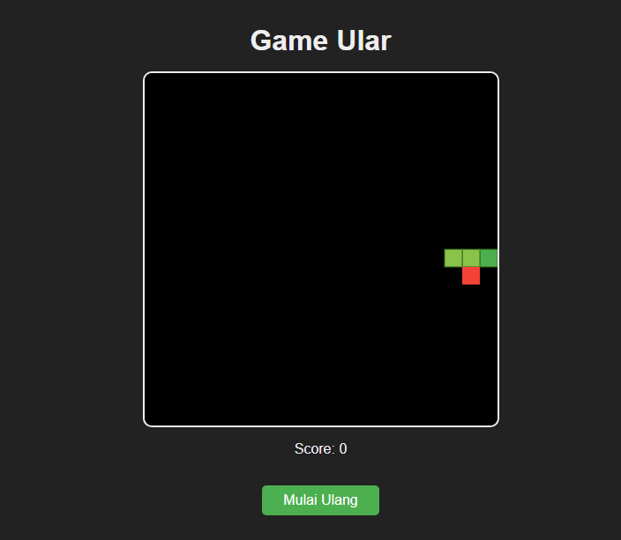

1. Game Klik Cepat

Index.html

<!DOCTYPE html>

<html lang="id">

<head>

  <meta charset="UTF-8">

  <meta name="viewport" content="width=device-width, initial-scale=1.0">

  <title>Klik Cepat</title>

  <link rel="stylesheet" href="style.css">

</head>

<body>

  <div class="container">

    <h1>Klik Cepat!</h1>

    <p>Klik sebanyak-banyaknya dalam 5 detik!</p>

    <button id="clickBtn" onclick="handleClick()" disabled>KLIK SAYA!</button>

    <p>Skor: <span id="score">0</span></p>

    <p id="status"></p>

    <button onclick="startGame()">Mulai Game</button>

  </div>

  <script src="script.js"></script>

</body>

</html>

CSS

body {

  font-family: sans-serif;

  text-align: center;

  background: #2c3e50;

  color: #ecf0f1;

  padding-top: 50px;

}

.container {

  background-color: rgba(0, 0, 0, 0.3);

  display: inline-block;

  padding: 20px;

  border-radius: 10px;

}

button {

  font-size: 20px;

  padding: 15px 30px;

  margin: 10px;

  cursor: pointer;

}

JS

let score = 0;

let isPlaying = false;

let timer;

function startGame() {

  score = 0;

  isPlaying = true;

  document.getElementById("score").textContent = score;

  document.getElementById("status").textContent = "Waktu dimulai!";

  document.getElementById("clickBtn").disabled = false;

  timer = setTimeout(() => {

    isPlaying = false;

    document.getElementById("clickBtn").disabled = true;

    document.getElementById("status").textContent = "Waktu habis! Skor akhir: " + score;

  }, 5000);

}

function handleClick() {

  if (!isPlaying) return;

  score++;

  document.getElementById("score").textContent = score;

}

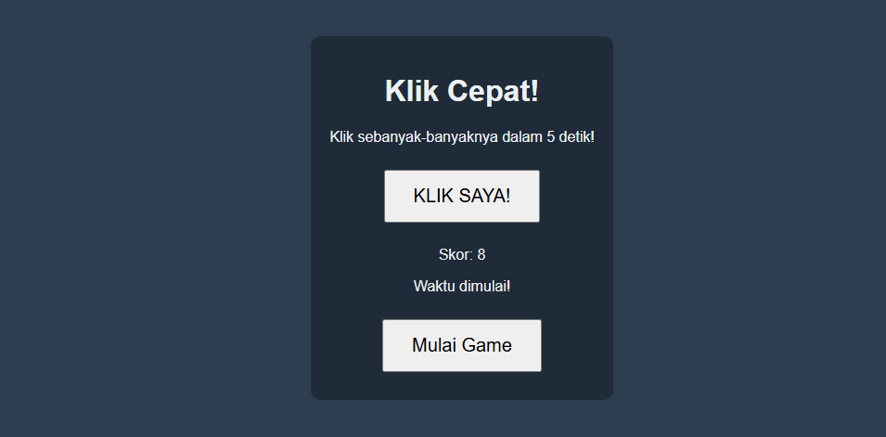

1. **Game Lompat**

Index.html

<!DOCTYPE html>

<html lang="id">

<head>

  <meta charset="UTF-8">

  <title>Game Cowok Lompatan</title>

  <link rel="stylesheet" href="style.css">

</head>

<body>

  <h1>Cowok Lompatan</h1>

  <div id="game">

    <div id="cowok"></div>

    <div id="rintangan"></div>

  </div>

  <p id="status">Tekan tombol spasi untuk lompat!</p>

  <script src="script.js"></script>

</body>

</html>

CSS

body {

  font-family: Arial, sans-serif;

  text-align: center;

  background-color: #d0f0fc;

}

#game {

  position: relative;

  width: 600px;

  height: 200px;

  margin: 50px auto;

  border: 2px solid #333;

  background-color: #fff;

  overflow: hidden;

}

#cowok {

  position: absolute;

  bottom: 0;

  left: 50px;

  width: 40px;

  height: 60px;

  background-color: #3498db;

  border-radius: 5px;

}

#rintangan {

  position: absolute;

  bottom: 0;

  right: 0;

  width: 30px;

  height: 50px;

  background-color: #e74c3c;

  animation: gerakRintangan 2s linear infinite;

}

@keyframes gerakRintangan {

  0% { right: -30px; }

  100% { right: 100%; }

}

.lompat {

  animation: lompat 0.5s ease;

}

@keyframes lompat {

  0% { bottom: 0; }

  50% { bottom: 100px; }

  100% { bottom: 0; }

}

#status {

  font-size: 18px;

  color: #333;

}

JS

const cowok = document.getElementById("cowok");

const rintangan = document.getElementById("rintangan");

const statusText = document.getElementById("status");

document.body.addEventListener("keydown", function(event) {

  if (event.code === "Space") {

    if (!cowok.classList.contains("lompat")) {

      cowok.classList.add("lompat");

      setTimeout(() => {

        cowok.classList.remove("lompat");

      }, 500);

    }

  }

});

let gameLoop = setInterval(() => {

  const cowokTop = parseInt(window.getComputedStyle(cowok).getPropertyValue("bottom"));

  const rintanganLeft = parseInt(window.getComputedStyle(rintangan).getPropertyValue("right"));

  if (rintanganLeft > (550 - 50) && rintanganLeft < (550 - 10) && cowokTop < 50) {

    statusText.textContent = "Game Over! Reload untuk main lagi.";

    rintangan.style.animation = "none";

    rintangan.style.right = rintanganLeft + "px";

    clearInterval(gameLoop);

  }

}, 10);

